Sample Cover Letter for Freshers
Your Street Address
Your City, state, zip
Date
Person’s Name
Company Name
Company Address
City, State, Zip
Dear (Mr./ Ms. Person’s Name):
Mr./ Ms. <insert person’s name> informed me about the post of <insert post title> in your company, <insert company name>.
I went through the job requirements listed on <insert where you saw the job listing>, and could relate a lot to myself. I have always been passionate about <Insert job profile> and being a fresher I believe that I can do very well in the position of <insert position title>. <Insert company name> is where I always wanted to work because <insert reason 1> and <reason 2>.
I do believe that I am the right person for this job because <reason 1> and <reason 2>. Since my strengths, <strength 1>, <strength 2> align with the job requirements, I do believe that I’ll be able to do well in this role.
I hope to meet you soon for the interview. I’ll give you a call in two days if that’s fine with you. Alternatively, you can call me on <number> to let me know a convenient time to catch up.
Thank you.

Dear Sir/madam
This is in regards to the freshers openings with one of your MNC for the role software tester/software developer.Hence I would like to apply for this position.
Presently, at the threshold of my career, with an expected Bachelor of Engineering degree(BE) in Information Science(ISE), I have been researching IT Firms,fit for my professional interests.
My key programming strengths are being C,C++,JAVA,J2EE,J2ME,JSP
I have done my Certification in Web Component Development using Java programming Technologies and also I have done my certification in developing mobile applications using java from so and so.
I expect you will need to know in detail about me in order to consider my candidature.So I have attached my resume for your review as the first step in the application process. I hope you will find my profile to be a strong indicator of what I would contribute as a skilled, hardworking member of your highly qualified strategic team.
Thanks & Regards

Sample cover letter 2 :
Dear Sir/Madam,
I am writing this letter to express my interest for the post of
Software engineer.
I consider myself familiar with C,C++,Oracle(10g),PL/SQL,Java.
I would appreciate the opportunity to interview/written-test with you at
your convenience and hope you will give the enclosed resume your favorable
consideration.
If you agree that my qualifications are a close fit to your needs, I would
be delighted to hear from you, you may reach me at phone or via email.
Thanks & Regards,

=====================================================

Sample cover letter 3 :
Dear Sir/madam,
I have attached my resume with this mail,i’m a fresher waiting to start off my career.i will work hard and will get along with new environment .I request you to find a suitable opening as per my profile thanks for your time.
Thanking you
=====================================================

Sample cover letter 4 :
Respected Sir/Madam
Sub:- Requsition for suitable job reg.
I am So , I have completed BE in Electronics &
Communication in college and university.
I have enclosed my curriculum vitae & I hope the details
furnished would satisfy.
Thanking you,

=====================================================

Sample cover letter 5 :
Dear Sir/Madam,
I have completed my engineering in Electronics and Telecommunication from University with 92% in year 2011. I have done my CERTIFICATION and Training in 3G (UMTS) from PVT LTD,City.
Learnt the structure & principles of UTRAN, Core Network, HSDPA Technology and studied concepts of Network Channels, Interfaces and Protocols. Along with this my Hand-on-experience in Configuring and Commissioning of Various Network Entities are well suited to the goals of your organisations.
I will look forward to meet you.
=====================================================

Sample cover letter 6 :
Respected Sir
I am so . I have done MCA in 2012 with 88%
Please see my resume in attached file for additional information.I believe that my strong technical skills and education will make me a very competitive candidate for job. I can be reached anytime via email or my cell phone
I would enjoy an opportunity to talk with you or someone in your organization to see where my skill set would be of the greatest benefit to your company. I look forward to speaking with you about the employment opportunity.
Thanks & Regards
=====================================================

Sample cover letter 7 :
Dear Madam/Sir,
This is so and so .I am a Fresher, I have knowledge in .NET , C, C++, SQLSERVER , Database Technologies.I am looking forward to be part of your esteemed organization to prove my abilities and serve the Company to my level best.Please find my resume attached in word format for your kind perusal and early response.
Thanks Regards
=====================================================

Sample cover letter 8 :
Dear Sir/Madam
I am exploring a job position in the field of Software Design and Development and have enclosed my resume for your consideration . I hold B.TechDegree in Computer Application.with 90% throughout in my academy I have got 6 Month experience as Trainee Developer in PVT LTD company Located in this city. My skills included Java, J2EE, Oracle and XML .
Looking for an opportunity where I can utilize my skills and abilities while being innovative, resourceful and flexible, Should you be interested candidature; I am certain that my presence in your team will prove to be beneficial to your organization.
Your Sincerely
=====================================================

Sample cover letter 9 :
Hello Sir/Madam,
I am just completed my Bsc(IT) from University.Details of my academic and other important information is mentioned in the resume attached with this request.
If there is any vacancy related to my field in your reputed company, then I request you to let me fulfill your requirement. Even though I am fresher I assure you that I will do my best.
Thanking you
=====================================================

Sample cover letter 10 :
Respected sir,
My name is So and so. I m fresher and have degree in Information Technology. I am putting forward my resume for the job in your reputed organization.
So kindly consider my candidature for the job and do the needful.
For your kind consideration the resume is attached herewith.
Thank you.

Cover Letter for Resume Format:
Your Name (Last Name followed by First Name)
Address (Complete Address)
Contact: +91- XXXXXXXXXX; Email: XXXXX@gmail.com
Respected HR Team,
I am submitting here with my resume for your perusal and favorable consideration for the post of “NAME OF THE POSITION” in your organization.
Review of my credentials indicates that I am a qualified YOUR QUALIFICATION (BRANCH NAME) from College Name, College Location(City), affiliated to YOUR UNIVERSITY NAME; possess comprehensive knowledge of YOUR SKILLS.Possess rich domain knowledge with comprehensive understanding of IMPORTANT CONCEPTS FROM YOUR SKILLS. Aware of IMPORTANT SUB TOPICS FROM YOUR SKILLS. Worked on YOUR PROJECT NAMES during the curriculum.
With exceptional communication and interpersonal skills, my self – confidence, innovative approach and quick adaptability to changing processes and trends have been my biggest assets.
I am seeking a challenging job that would synergize my skills and experience with the objectives of the organization.
The above credentials along with my enclosed resume make me ideally suitable for a position in your organization. I would appreciate an opportunity for a personal interview.
Thanking you in anticipation of a favorable reply.
Yours sincerely
YOUR SIGNATURE
How to Use the Above Cover Letter:
- Read the Cover Letter once Completely and then Start filling the Cover Letter with your details.
- I highly recommend you to Keep the Sections in BOLD, Which I’ve done in the Cover Letter.
- You can use the above Cover Letter for Any Type of Position. Just replace the required fields and Use it.
- If you don’t like any of the fields are sections in the above cover letter then go ahead and edit them.
Sample Cover Letter for Resume:
I’m Providing the Cover Letter Sample for Software Test Engineer Position. It’s not a document, It’s an Image.
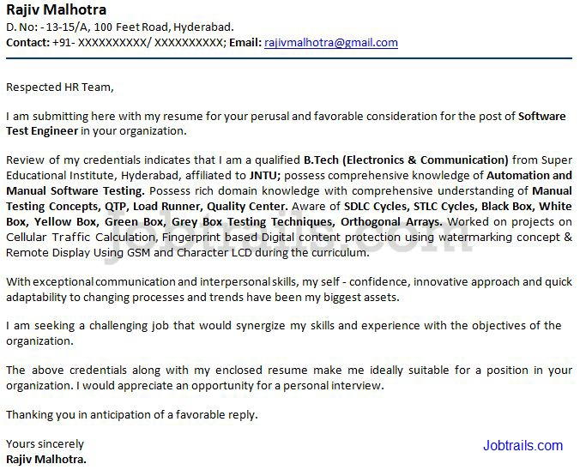
Very Important Note:

